Shruti Hindocha

Data Analysis

KICKSTARTER CAMPAIGN

Table of Contents

1 Conclusions 2

1.1 Success or failure based on category 2

1.2 Success or failure based on sub-category 3

1.3 Success or failure based on category and time of the year 4

2 Data Set Limitation 4

2.1 Currency 4

3 Further Analysis 4

# Conclusions

## Success or failure based on category



* Considering world-wide data, majority of projects that participated in the kick starter project fell under the following categories (in descending order)
  + Theatre
  + Music
  + Film & video
  + Technology
* Out of the four categories, from world-wide data “music” saw more successes whereas “technology” was the least successes.
* However, it is important to note that the world-wide data is highly dependent on the data collected in the US. Out of 4114 projects, 3038 were conducted in the US.
* It can be concluded that, major stakeholders of the Kickstarter belong to the arts industry or community.

## Success or failure based on sub-category

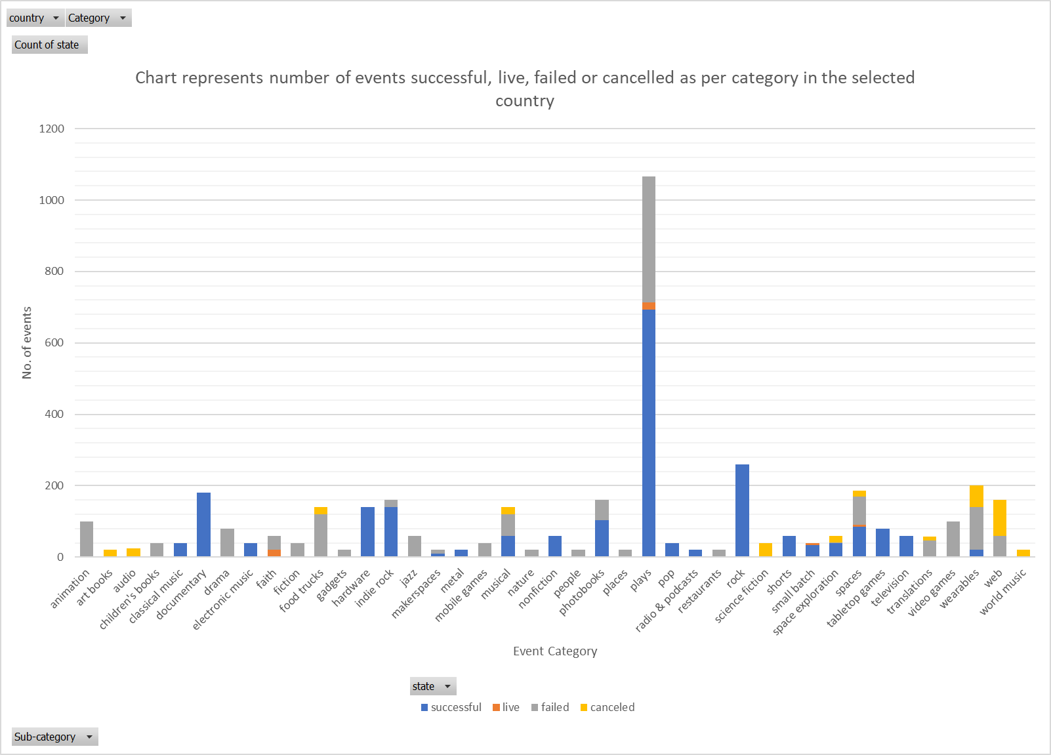

* Again considering world-wide data, majority of the projects that participated in the kick starter project fell under the “**play**” subcategory. Other popular subcategories include
  + Drama
  + Rock
  + Food trucks
  + Hardware
  + Jazz
  + Musical
  + Photobooks
  + Rock
  + Tabletop games
  + Wearables
  + World Music
* Out of the above listed sub-categories, the most successful ones are
  + Drama
  + Hardware
  + Jazz
  + Rock

## Success or failure based on category and time of the year

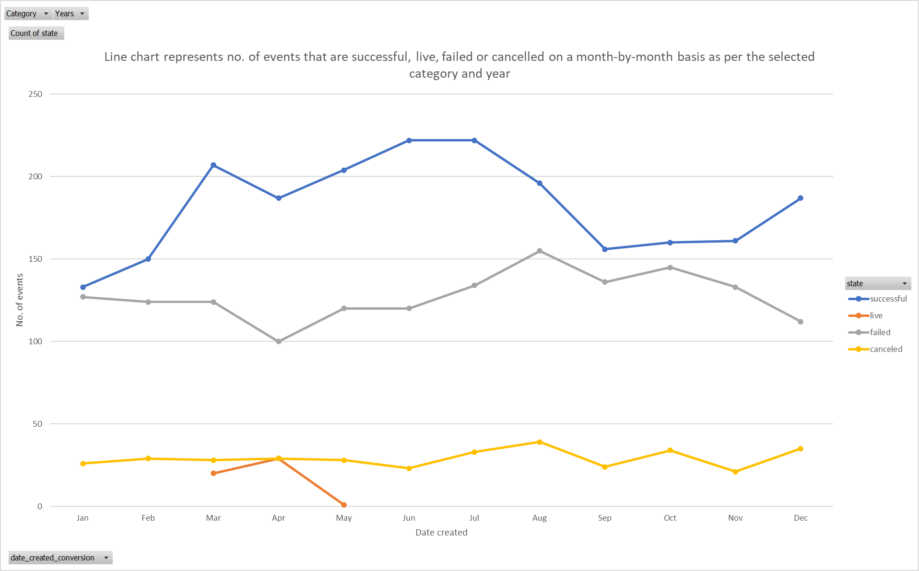

* + Based on world-wide data and throughout all the year, successful events occur between June and July.
  + There is a significant decline in success of events between July and August in all categories. Also, there is a trend of decline in success in the month of April.

# Data Set Limitation

## Currency

* + “Goal” and “pledged” data in the dataset is provided in different currencies.
  + Insufficient data to be able to measure the rate of fund collection.
  + Big portion of the data is retrieved from the US, therefore insights gained from world-wide data would be less reliabel for other countries.

# Further Analysis

* + Measure of success by creating a staked line graph to compare percentage funded for all the categories.
  + Evaluate duration of campaign - Comparison of launch date vs deadline date using line plot (with markers), filter by success, failure, cancelled, live.
  + Classify data by region- US, UK, Europe, SE Asia for data analysis .
  + Bar graph to represent average donation – filter by year, country, category and subcategories.
  + Bar graph to evaluate progress of cancelled events before they were cancelled – filter by year, country, category and subcategories.